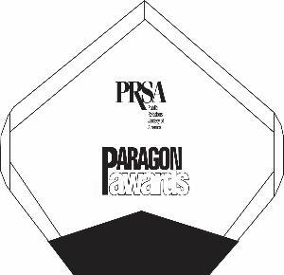
2026 PRSA PARAGON AWARDS – ENTRY FORM
Please submit this form with each entry.
Additional forms are available online at www.PRSAWIS.org.

- Entry Title:
- Award Category and Number:
- Name of Organization:
- Name of Agency (if applicable):
- Contact Name:
- Phone:
- Email:
If your entry wins, please advise how you would like the award engraved. If the character limit is exceeded, the Paragon Committee will determine the content.
- Name of organization or individual (17 character limit):
- Name of campaign or client for which award was received:
- Please list the name of the organization or person(s) who you’d like recognized at the banquet, should your entry win:
- Briefly describe your entry. This statement will introduce your entry to judges and be used at the awards banquet, should it win:

DEADLINE: Entries and payments need to be received no later than 5 p.m. CDT on Monday, April 6, 2026. Entries and payments received after the deadline will not be considered.
SUBMIT TO: prsasewi@gmail.com
CONTACT INFORMATION FOR QUESTIONS
Questions regarding the entry process or entry categories may be directed to PRSA Administrator & Entry Coordinator (prsasewi@gmail.com) or Dave Racine, PRSA Board Member (dracine@punch-pr.com)

